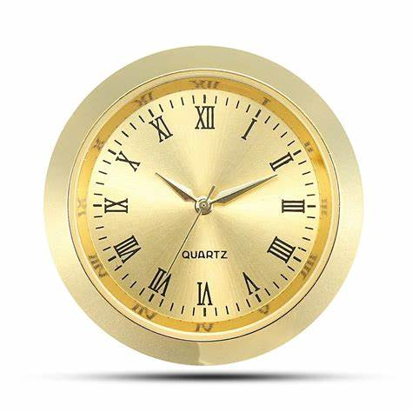**Description:** **Quartz** refers to a type of clock movement that uses a quartz crystal to keep time with high accuracy. Quartz clocks are powered by a battery and work by sending an electric current through the quartz crystal, which vibrates at a precise frequency (usually 32,768 times per second). These vibrations regulate the movement of the clock’s hands, ensuring accurate timekeeping.

Quartz clocks became popular in the 20th century due to their affordability, low maintenance, and superior accuracy compared to mechanical clocks. They are widely used in wall clocks, wristwatches, and digital timepieces. Many well-known brands, such as **Seiko, Casio, Citizen, and Lorell**, produce quartz clocks in various styles, from simple and functional to elegant and decorative designs.